FPGA-based cameras – uviSpace
1 FPGA Board physical setup
The main component in the cameras is a Terasic DE2-115 board containing an Altera Cyclone IV FPGA. This is a fairly big FPGA with 115k logic elements, suitable for complex digital projects. Connected to the main board, through the 40-pin GPIO , there is a Terasic D5M 5 Mega pixel camera.
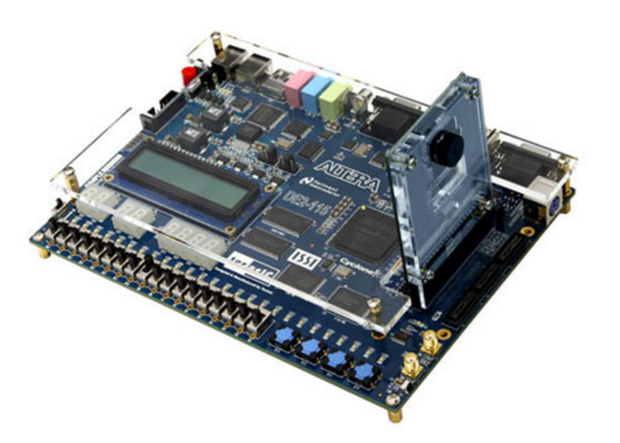
Fig. 1. DE2-115 board and D5M camera connection.
In this project the 40-pin straight female header in the camera is changed by a 90 degree 40-pin header so the camera points down. 4 of these cameras are located in the ceiling of the laboratory like the following figure shows. The cameras are located so the field of view of the cameras touch with each other without overlapping. This is done this way to maximize the area the cameras can see. Problems to locate the car in the borders of the cameras should be solved by software.
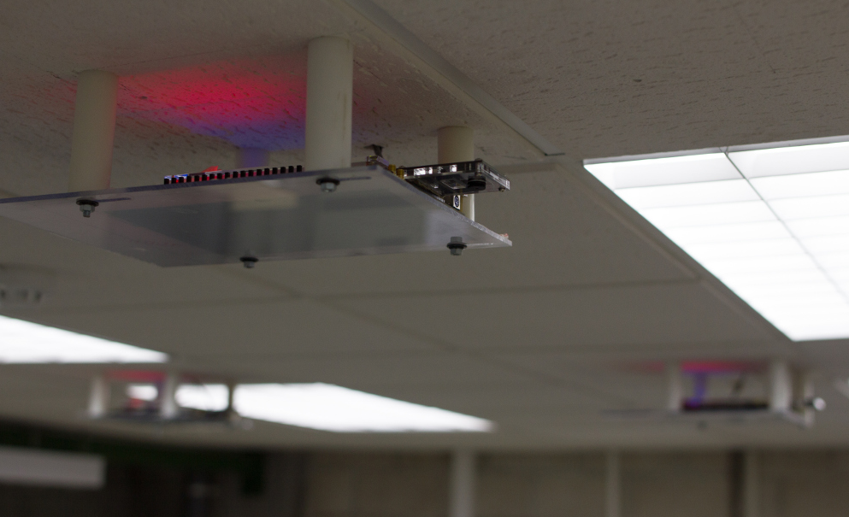
Fig. 2. Setup of 4 cameras in the ceiling of the laboratory. Better photo if it is available

2 FPGA hardware
2.1 Quartus and SOPC-Builder
The FPGA project is done using Quartus II and SOPC-Builder (Version 12.1). Quartus II is the program to design and compile the hardware for the Altera FPGAs. SOPC-Builder is a tool inside Quartus II (Tools-> SOPC-Builder) to easily develop systems on chip (SoCs): Digital systems with all or almost all elements (processor, memory and peripherals) in a single chip. The evolution of this program is called Qsys and it is the program used in newer versions (after 13) of Quartus II. SOPC-Builder and Qsys are tipically used to develop systems based on the soft-processor Nios II. They use Avalon standard buses to ease the development of SoCs:
- Avalon Memory-Mapped (MM): It contains the signals needed to develop a master-slave bus: Adress Bus, Data Bus, READ, WRITE, etc. There are two tipes of Avalon MM interfaces: Avalon MM slave and Avalon MM Master. The communication is always initiated by the masters ordering/writing to or asking/reading from the slave.
- Avalon Streaming (ST): point to point connections for fast data transmission. There are also two types: source and sink of data.
- Avalon Interrupt: point to point connection between two systems: the one generationg and interrupt and the one who services it.
- Clock: point to point connection between clock source and clock sink.
- Reset: point to point connection between reset source and reset sink.
- Avalon Tri-state Conduit (TC): For tri-state controllers. They allow the connection of different components with third state capabilities in the PCB using small number of signals, saving pins and space in the board.
- Conduit. Point to point connection between two conduit signals. It is used when none of the previous interfaces is useful. It is tipically used to export signals outside of Qsys and represent the particular interface for some chip. It is also used to connect two componnets with custom user-defined interface between them.
Using the standard buses the connection between components is fast because Qsys knows their signals and its meaning. In a single click a memory mapped slave can be connected to a processor, saving time and avoiding errors. SOPC Builder and Qsys create a lot of logic automatically. In Avalon MM buses for example they create the logic needed to implement a desired address map. SOPC Builder and Qsys also have a big library of IP (Intelectual Property) cores that are well tested and documented. This permits the developer to focus the efforts on the components that are special for the application.
2.2 FPGA System overview
The system implemented in this Project is depicted in Fig. 3. The biggest part of the system is a NiosII processor system defined in SOPC Builder. The rest of the system is defined directly in Quartus II.
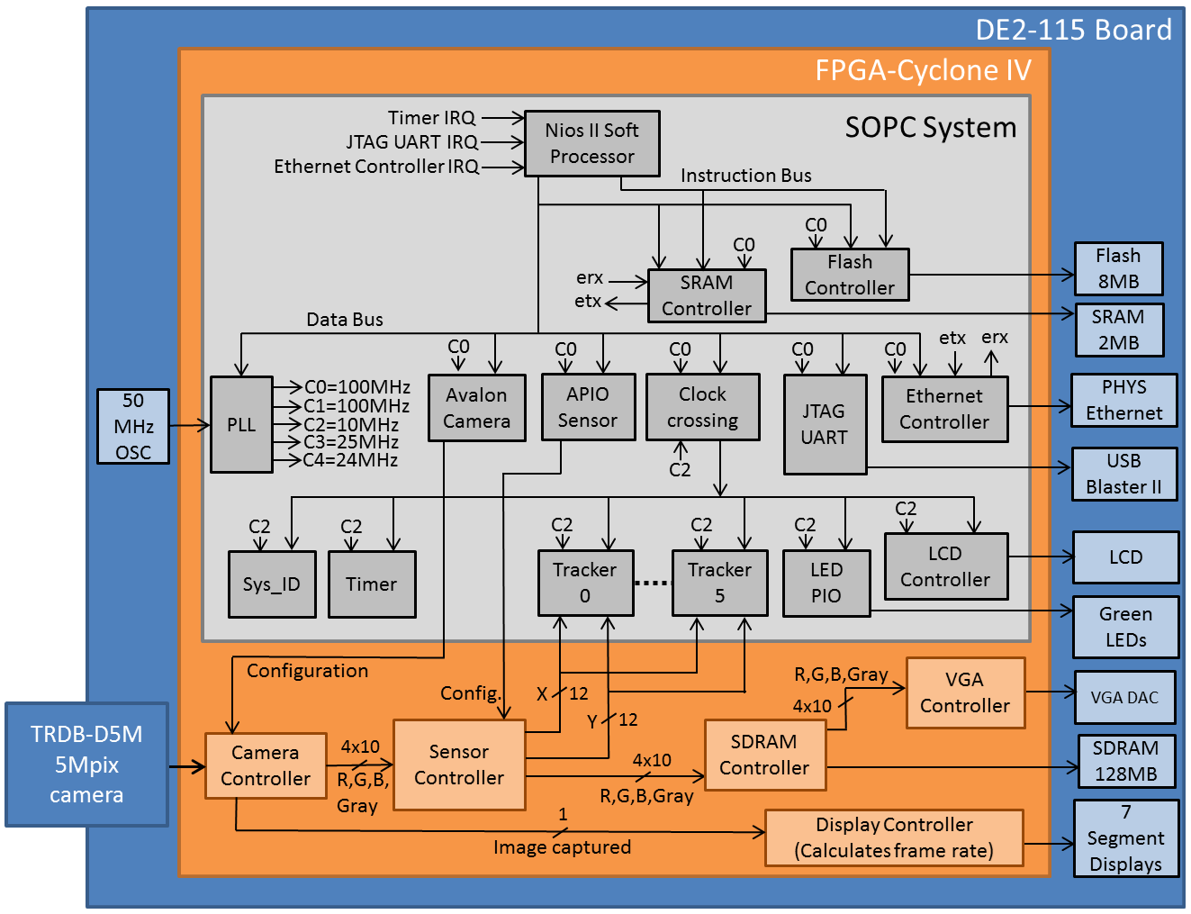
Fig. 3. FPGA Hardware.
The SOPC Builder system (Gray part in Fig. 3) is composed by:
- Nios II processor: soft-processor controlling all the hardware components. It is in charge of the initialization of all components and the communication through Ethernet. Communications permit remote control of the system via commands. The instruction bus and data bus of the processor are connected to both SDRAM and Flash memory, so both this memories can be used as data and program memory.
- SRAM Controller: It controls the 2MB of volatile SRAM available in the board. When debugging using the Nios II EDS it is used as program and data memory for the Nios II processor. When the development is finished and the program for the processor is loaded into the non-volatile flash memory, the SRAM memory is only the data memory for the system.
- Flash Controller. It controls the 8MB Flash non-volatile memory available in the board. When debugging using the Nios II EDS it can be used to store the MAC address of the board or any other configuration/calibration data. When the program is finished and the board does not need the computer anymore the Flash memory is used as program memory to store the program for the Nios II processor.
- PLL generates the clocks for the system from a 50MHz source. C0 and C2 are used inside SOPC Builder. C0 to C4 are exported outside SOPC Builder for usage in the Quartus II components (orange part). Some of the clocks generated in SOPC-Builder and exported are not used in Quartus II side because there is another PLL there. This PLL should be removed and the system should use the clocks generated in the main PLL inside Qsys.
- Avalon Camera: provides a register interface for the configuration of the Camera Controller component from the Nios II processor.
- APIO Sensor: provides a register interface for the configuration of the Sensor Controller component from the Nios II processor.
- Clock-crossing I/O: connects buses with different clocks. In this case it connects the secondary Avalon MM data bus (sourced by C2) with the main Avalon MM data bus (sourced by C0).
- JTAG UART: permits communication with Nios II EDS to use the Nios II use the Nios II console, load the programs in SDRAM and do step-by-step debugging. It has an interrupt line connected to the Nios II with highest priority 0 (lower number means higher priority).
- Ethernet controller: Controls the PHYS Ethernet chip in the board implementing the physical layer of the TCP/IP protocol. It can do DMA and read and write directly to the SRAM memory (data memory). Its interrupt has the lowest priority in the system (number 2) .
- Sys_ID. This component stores a number identifying the system and a time stamp when the Nios II system is generated in SOPC Builder. The Nios II EDS checks this two values before loading a Nios II program to ensure that the system connected is the correct target for the software project (these 2 numbers are passed in the sopc_info file used to generate the software projects).
- Timer: Timer used by the Real Time Operating System (RTOS) running in the Nios II to schedule its tasks. After the JTAG UART this timer should have (and has) the highest priority interrupt (number 1).
- Tracker0 to Tracker 5: Explanation by Javier.
- LED PIO: GPIO peripheral to control from Nios II the green LEDs 0 to 7 in the board.
- LCD Controller: Used to control the LCD screen from Nios II. It is used by the software to print some information like the IP address.
Quartus II part (orange part of Fig. 3) is composed by:
- Camera Controller: It is in charge of camera configuration, RAW data capture from the camera and data conversion from RAW to RGB and grayscale. There are 4 buses of 10 bits each: one for each RGB channel and one more for gray scale channel. They have 10 bits because…
- Sensor Controller: it implements the image processing for the detection of robots marked by red triangles. For that task it used only the red channel from the Camera Controller (check and improve this explanation). The output of the algorithm are the x and y coordinates of…. X and Y are 12 bit buses. X and Y are sent to the trackers to… Another output is the RGB and gray images that are stored to SDRAM memory through the SDRAM controller.
- SDRAM Controller: it controls the 128MB SDRAM memory in the board. It stores…. Why this storage is needed I don’t know.
Red LEDs are not depicted in Fig. 3 because they are connected to a lot of modules. RED leds show useful information for the programmer:
- Red LED 17: Flags that the camara has been configured I think
- RED LED 16: Flags that Camera Controller is providing video output.
- RED LED 15: Flags that the input of VGA controller is connected to the output of the output of the SDRAM controller. If the Camera Controller is providing image it should appear on the Screen connected to the VGA port.
- RED LED 14: Flags that the processor is telling the camera to acquire images.
- RED LED 13
- RED LED 12
- RED LED 11
2.3 FPGA Hardware compilation and file organization.
The process to develop and compile the FPGA project is:
- Edit the Nios II System using SOPC Builder.
- Save and Generate the SOPC Builder project. This generates in the project folder:
  - DE2_115_SOPC.sopcinfo: XML file containing the structure and settings for the components in the Nios II System. This file is used by Nios II EDS to know the hardware in the system and ease Nios II programming.
  - DE2_115_SOPC.v: Main HDL file for the Nios II system, instantiating all the IP cores that were previously added in SOPC Builder.
  - Rest of HDL files for Nios II system: A bunch of .v files are copied in the project folder. They are the source files for all the components added in SOPC Builder. Altera library IP cores (like Flash Controller, SRAM Controller, LCD Controller, Timer, Sys_ID) are copied from the Altera installation folder. The rest of IP cores (Avalon Camera, APIO Sensor, Trackers and Ethernet Controller) are copied from folders inside the project folder (ip/Avalon_camera, ip/apio_sensor, ip/Avalon_locator and ip/eth_ocm).
- Instantiate Nios II System and other components in Quartus II: The Nios II system, represented now by DE2_115_SOPC.v is a component and can be used in Quartus II designs using DE2_115_SOPC as component name. To use the Nios II system and connect it to other components, the file DE2_115_WEB_SERVER.v is created. DE2_115_WEB_SERVER.v defines the main entity for the FPGA hardware project. The name of this entity should be the same name as the project name (DE2_115_WEB_SERVER) because Quartus II starts the compilation looking for the entity with the same name as the project. Inside DE2_115_WEB_SERVER.v the Nios II System (DE2_115_SOPC) is instantiated along with the rest components in the Quartus II part of the system (orange part of the Nios II), that is: Camera controller, Sensor controller, SDRAM Controller, VGA Controller and Display Controller. The source files for all this components are in folders inside the project forlder (camera, display and sensor). In DE2_115_WEB_SERVER.v the components are connected to the FPGA pins using names (like LEDR, CLOCK_50, etc.). The relation between this names and the actual pins on the chip is in the DE2_115_WEB_SERVER.qsf. This file can be generated for any DE2-115 board using the System Builder program in the DE2-115 CD-ROM documentation.
- Add compilation files to Quartus II: All HDL files used in the project should be added to the files tab in Quartus II (left upper part of the program) so the compiler can find them. The following files should be added:
  - DE2_115_WEB_SERVER.v: main file containing highest level entity.
  - DE2_115_SOPC.v: definition of the Nios II system.
  - DE2_115_SOPC.quip: this file imports the rest of the files describing the components used in SOPC Builder to describe the Nios II System. Quip files are used to import a group of HDL files together.
  - Rest of quip files for the Quartus II part of the system (orange part in Fig. 3): display/vga.quip, display/display.quip, camera/camera.quip, etc.
- Add libraries: eth_ocm component is little special. Its source files are added as a library. So in Quartus II->Assignments->Settings->Libraries, ip/eth_ocm folder is added.
- Compile the project: Press compile design or Processing-> Start Compilation. Analysis&Synthesis converts HDL design to the FPGA hardware. The Fitter does the Place & Route of the circuit (locates the circuit in the specific device assigned to the project and interconnects all the elements). The assembler generates the .sof file used to program the FPGA.
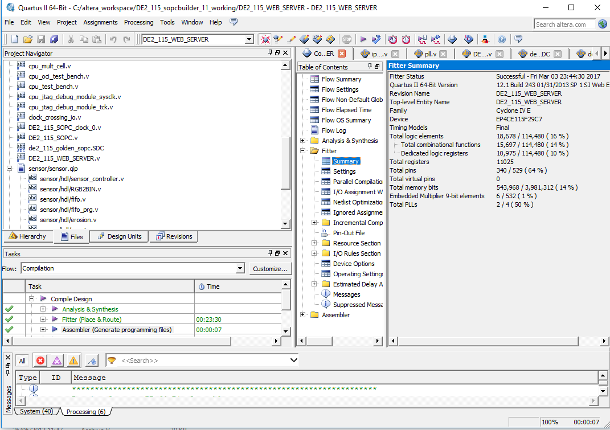
Fig. 4. Quartus II program showing the Files tab and a successful compilation.

3. FPGA software
2.1 Software project overview
The software project to run in the Nios II processor is located in [project folder]/software. Inside this folder there are two projects:
- SocketServer: application project where the user locates the application-specific code. Explain more the functionality of each file.
- Socket_Server_bsp: it contains all the code that abstracts the hardware to the user. When generating the BSP the program asks for the .sopc_info file (DE2_115_SOPC.sopc_info in this case) and the program automatically loads the drivers needed to the drivers folder. Important files and folders in the BSP are:
  - Drivers: folder with the drivers of the components added in SOPC Builder. For custom components the drivers have to be manually added to drivers folder or added as a library component to altera installation folder so this process is automatically performed.
  - HAL (Hardware Abstraction Layer): gives support to the standard C library to Nios II processor.
  - UCOSII: files of the uC-OS II Real Time Operating System (RTOS). In this case this RTOS is used to schedule several tasks in the processor.
  - System.h: contains macros for the addresses of the Nios II system components. Using this macros is safer than directly using the addresses in SOPC Builder because if changes in the address map are lately done, all addresses in the system can be fixed regenerating the BSP.
The BSP can be edited by doing right click->Nios II->BSP Editor. Some common configurations are: add Ethernet support using Iniche Stack, add uC-OS II, implement of zipfs file system, use hostfs file system, use reduced (but slower) C std libraries, etc.
2.2 Import a software project
Usually, when one starts a new project both projects are generated at the same time using File->New Nios II Application and BSP From Template. In this case the projects are already created so they have to be imported into the workspace. To do this go to: File->Import->General->Existing Projects into workspace->Select root directory [project folder]/software -> Click copy projects into workspace if desired->Finish. I personally choose [project folder]/software as workspace and do not copy the projects into workspace.
2.3 Change sopc_info file location in the BSP
The BSP uses global location to find the .sopc_info file. When changing the location of the folder, the path of the .sopc_info file has to be changed before generating the BSP again. It can be done in the settings.bsp file inside the BSP project under the <SopcDesignFile> entry.
2.4 Software project compilation
To compile the system:
- Generate BSP: Right click Socket_Server_bsp->Nios II->Genrate BSP.
- Compile BSP: Right click Socket_Server_bsp->Build.
- Compile application: Right click SocketServer-> Build. The makefile combines the BSP and application compilations to generate a single output .elf file located inside the application folder. In this case it is called SocketServer.elf. This file is the program for the Nios II processor.
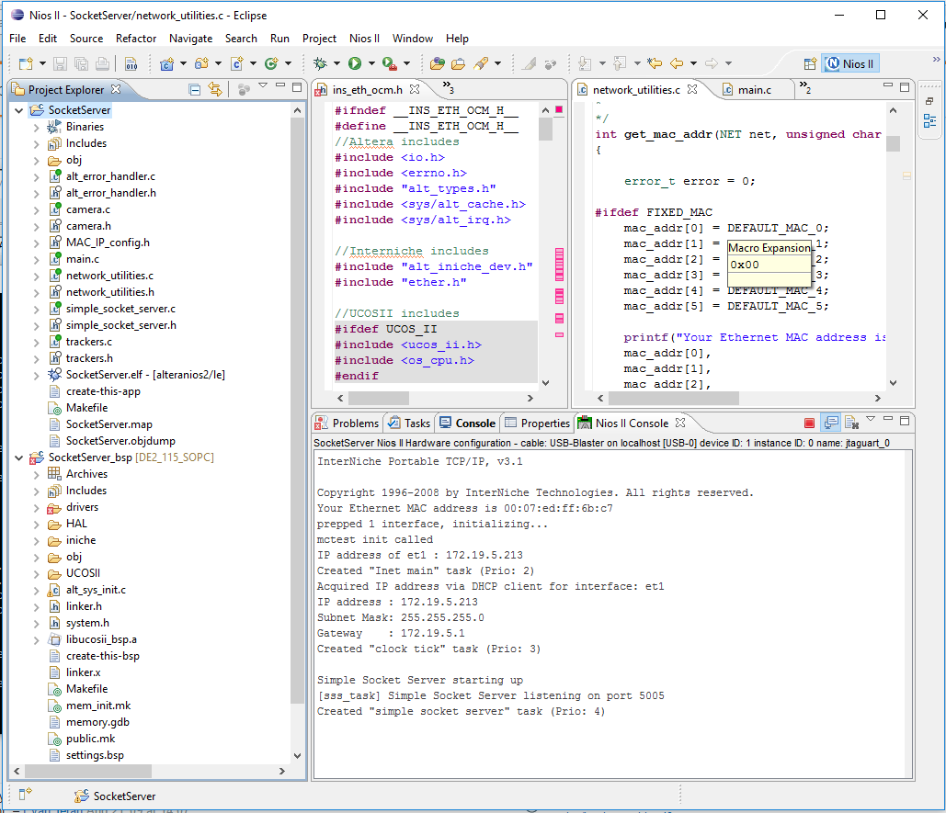
Fig. 5. Nios II EDS showing the application and BSP projects.

2.3 MAC and IP
The software contains its MAC and IP settings in the MAC_IP _config.h file.
- Using DHCP: If USEDHCP macro is defined in the file, the board is going to ask an IP address via DHCP using the MAC written inside this file. If DHCP fails (after 2 minutes) the board sets the IP address written in this file.
- Fixed IP: If USEDHCP macro is NOT defined in the file (i.e. the line commented): the MAC and IP used are directly the ones written in this file, and DHCP is not used.
The MAC and IP address currently used in the Department of Technology of the UVigo are:

Table 1. MAC and IP adresses for the cameras in the laboratory of the Uvigo Electronic Technology Department.
 | MAC | IP address
Camera 1 | 00-07-ED-FF-6B-C7 | 172.19.5.213
Camera 2 | 00-07-ED-FF-D7-8E | 172.19.5.214
Camera 3 | 00-07-ED-FF-43-55 | 172.19.5.215
Camera 4 | 00-07-ED-FF-AF-1C | 172.19.5.216

4. How to load hardware and software in the FPGA board
We have 2 different options:
- While debugging. In this case the board is connected to the PC for debugging. The console in the Nios II EDS can be used. In this situation both the program and data of the Nios II processor is stored in the SRAM memory. We provide this version in DE2_115_sopcbuilder12 folder:
  - In the Nios II processor component in SOPC Builder reset and exception vectors are pointing to the SRAM controller component (so the SRAM becomes its program memory). They should be pointing there in the folder provided.
  - Compile the SOPC Builder project and compile using Quartus II.
  - Set the RUN-PROG switch in RUN position and switch on the board.
  - Load the DE2_115_WEB_SERVER.sof file into the FPGA using the Quartus Programmer in JTAG mode.
  - With the BSP pointing to the last version of the DE2_115_SOPC.sopcinfo Genrate the BSP and recompile the BSP and software projects.
  - Load the SocketServer.elf into the SRAM memory doing: Nios II EDS->Right click SocketServer->Run as->Nios II Hardware. The first time you load a .elf you have to configure the loading processes using : Right click SocketServer->Run configurations. There the board can be detected. Uncheck Ignore mismatched System ID or ignore mismatched system timestamp if you are sure that .elf is targeting the board connected (sometimes it fails even the software project is generated from the .sopc_file of the system in the board).
  - The program is loaded and it starts. You can use the console as std input and output.
- Stand-alone board: in this case the program of the Nios II is loaded into the non-volatile flash memory and the configuration of the FPGA is loaded into the non-volatile EPCS memory availables in the board. When the board is configured using this option, during the start-up the FPGA is loaded from the EPCS and the Nios II starts reading its program from the flash memory, that is now its program memory. The SRAM memory is one more time the data memory of the processor. This is the mode used to put the cameras in the ceiling of the lab. We provide this version in the DE2_115_sopcbuilder12_flash folder. The steps to do that: (this steps doesn’t work !!!!!!!! check how to get to this project from the debugging version!!!!!!)
  - Delete old version of DE2_115_sopcbuilder12_flash.
  - Take the DE2_115_sopcbuilder12 project and copy it, change the name to the copy by DE2_115_sopcbuilder12_flash.
  - In the Nios II processor component in SOPC Builder set the reset and exception vectors pointing to the Flash controller component (now the Flash component is the program memory of the system).
  - Compile the SOPC Builder project and compile using Quartus II.
  - Convert the DE2_115_WEB_SERVER.sof file into DE2_115_WEB_SERVER.pof file using Quartus II->File->Convert Programming file. It is generated in the project folder. Choose EPCS64 as device and Active programming as settings, and DE2_11_WEB_SERVER.sof as input file.
  - Set the RUN-PROG switch in PROG position and switch on the board.
  - Load the DE2_115_WEB_SERVER.pof file into the EPCS memory using Quartus II programmer in Active-Serial mode.
  - Switch off the board, switch the RUN-PROG switch to RUN position and switch on the board again. Now the FPGA is configured from the EPCS.
  - The previous .elf used in debug mode can be used. However, if you need to recompile it genrate the BSP and recompile the BSP and software projects again.
  - In the Nios II EDS right click in SocketServer project->Nios II->Flash programmer. Click File->New->Get Flash programmer system from SOPC Information File->Select the .sopc_info file generated in the last compilation (the one where Nios II reset and exception vectors are pointing to the flash memory) ->click OK, add the SocketServer .elf file and press start. The .elf file should be downloaded into the flash.
4. Migration of hardware project to Qsys
An attempt to migrate this code to Qsys was done. Using Qsys instead of SOPC Builder permits to use the newer versions of Quartus like Quartus II. Otherwise old Quartus versions have to be used. The last version with SOPC Builder is the Quartus II 12.1. This version contains both Qsys and SOPC Builder and permits the migration from SOPC Builder to Qsys.
Several attempts were done to migrate the design to Qsys without success.
- First the less number of modifications to the design were done. The design was open with Qsys and migrated to Qsys. The SOPC Builder files are automatically sent to a Back Up. In this process Qsys erases all .quip files in Files Tab of Quartus II. Qsys saves all data in DE115_SOPC/systhesis folder. The DE115_SOPC/systhesis folder DE115_SOPC.qip is added to Quartus. The rest of .qip files for the components added in Quartus II (like sensor or camera) are added too. The design compiles. The processor works but Ethernet do not. Some file is probably missing in the compilation. The compilation process does not break but the design is not fully completed.
- Starting from zero. The design was open with Qsys, regenerated. All files in Files tab in Quartus II are removed. In this scenario when the compilation crashes because files are not found, they are supplied one by one. The project compiles but the end result seems worse than before because the program cannot be loaded into the Nios II processor.
In this scenario few more attemps to directly from SOPC Builder to Qsys can be done. If there is no success the best option is to start from bottom a new project and go adding functionality to it. First the Nios II and its memories. If it works, Ethernet capabilities can be added, and so on. The error probably is in some files missing for the Ethernet controller or some files missing in one of the multiple IP cores added with Quartus and the IP Wizzard. This Wizzard IPs usually come with some files to configure some tables of data needed to do the functionality of the IP. If this is the case the compiler can compile leaving that memories empty and later the IP core functionality is wrong.

